Erasmus+ KA220-YOU - Cooperation partnerships in youth (KA220 YOU)
Agreement No. 2024-1-ES02-KA220-YOU-000245165

WellMe
Wellbeing Hubs. Building a sustainable learning environment for Youth in Local communities

WP3.1. Creating Hands-On Training for Implementing the Five
Elements of Wellbeing

Module 2



Contents
1. Introduction 3
1.1 Theoretical Background of the Module No 2….. 3
2. Module Activity 4
2.1 Objectives of the Activity 4
2.2 Step-by-Step Guide of the Activity 5
3. Conclusion 6
Αnnex3. 8

Funded by the European Union. Views and opinions expressed are however those of the author(s) only and do not necessarily reflect those of the European Union or the European Education and Culture Executive Agency (EACEA). Neither the European Union nor EACEA can be held responsible for them.

El proyecto “WellMe (Wellbeing Hubs. Building a sustainable learning environment for Youth in Local communities), 2024-1-ES02-KA220-YOU-000245165” está cofinanciado por la Unión Europea. Las opiniones y puntos de vista expresados en esta publicación sólo comprometen a sus autores (los socios del proyecto) y no reflejan necesariamente los de la Unión Europea ni los del Servicio Español para la Internacionalización de la Educación (SEPIE). Ni la Unión Europea ni la Agencia Nacional SEPIE pueden ser considerados responsables de ellos.

Introduction

1.1 Theoretical Background of the Module No 2: Bounce Back Stronger
Provide a concise overview of the theoretical framework that supports the module. The purpose of this section is to equip trainers with the necessary conceptual understanding before moving to practical implementation.⚠️ Important: The theoretical background should be clear, focused, and directly linked to practice.
This section should cover the following:

- What is this module about?
-Define the key concepts related to the module. (Maximum 500ch)

The cultivation of resilience, growth mindset, and adaptability represents a foundational triad in contemporary youth development and wellbeing education. In an era characterized by social uncertainty, technological transformation, and evolving labor markets, young individuals must be equipped with the psychological resources and cognitive flexibility necessary to navigate change effectively. Ιn this module we will delve deeper into the above concepts and see practices and approaches that contribute to the development of these skills

Resilience in general is the process and outcome of successfully adapting to difficult or challenging life experiences, especially through mental, emotional, and behavioral flexibility and adjustment to external and internal demands.
Adaptability is a crucial life skill for people of all ages, as it enables individuals to respond effectively to unexpected changes and evolving demands. In an increasingly dynamic world, being adaptable supports personal growth, resilience, and success across both professional and everyday contexts.
Growth Mindset is a mindset that emphasizes the potential for change and improvement, in contrast to the "Fixed Mindset," which holds that abilities are innate and unchangeable. This distinction is crucial for developing inner strength and resilience.

-Briefly explain why these concepts are important in local/rural youth work contexts. (Maximum 500ch)

In today’s world of constant change, uncertainty and increased demands, young people need skills that allow them to respond effectively to challenges and maintain their mental balance. This educational material focuses on cultivating three basic life skills: resilience, adaptability and growth mindset in order young people can “navigate” in their adult life smoothly and effectively which is particularly important in local and rural contexts where young people may have limited access to opportunities, services and support networks.

- Clearly connect the Module to the goals of the WellMe – Wellbeing Hubs project. (Maximum 500ch)

The project aims, among other things, to support young people to discover their strengths, make positive choices and build a brighter future for themselves and their communities. The skills of resilience, adaptability and growth mindset are essential core skills for this goal.

Module Activity

2.1 Objectives of the Activity
Clearly state the objectives of the selected Activity. Specify what participants (youth) are expected to gain from the learning process and how it is connected with the module.
⚠️ Important: Objectives should be specific, practical, and action-oriented.
This section should cover the following:

- Learning outcomes:
-The knowledge participants will develop.
-The skills they will strengthen.
-The attitudes or perspectives they are encouraged to reflect upon.
(Maximum 500ch-Use Bullet points)

Knowledge
- Understanding that failure is a common part of personal and professional growth.
- Recognize real challenges of life in the countryside
- Identify lessons from failure
- Analyze the stages of recovery after a failure
Skills
- Manage challenges or difficulties
- Recognize strategies to overcome them.
- Develop resilience, perseverance, and adaptability.
- Create small realistic action plans

Attitudes
- View failure as an opportunity for learning and growth.
- Strengthening a growth mindset and openness to personal development
- Remain positive in difficult situations

- The connection between the exercise and the module goals.
(Maximum 500ch)

This activity allows learners to learn from the failures of people who ultimately succeeded or not, demystifies failure and teaches them through a group activity that in life things do not go as planned. This results in them gaining self-confidence and increasing the skills of resilience and growth mindset.

References: The activity is inspired by experiential learning approaches in adult education and reflective practice (Kolb, Mezirow), using anonymized narratives of well-known figures who experienced failure.

2.2 Step-by-Step Guide of the Activity
In this part describe the activity, clear, structured, and easy to replicate in different youth work settings.
⚠️ Important: Provide only the necessary information.
In this section, provide:

- Title of the Exercise:
The Teaching Value of Failure.

- Duration:
75-90 minutes.

- Target Group (audience):
N/A

- Materials Needed:
Paper, pens, board, printed stories from the annex,

- Step-by-Step Implementation:
The trainer, after dividing the trainees into small groups of 4-5 people, distributes narrative stories that are at the end of this exercise or others of his/her own that he/she wants to utilize. He/she does not reveal at the beginning who the protagonist of the story is. The trainees in small groups read and study the story.

Each group answers in writing way:
- Where exactly is the failure in the story you read?
- What lesson/lessons can we take from this story?
- What skills does he/she need to deal with the condition he/she is experiencing?

After each group presents the answers to the above to the plenary, the trainer introduces the protagonist of the story and a discussion follows about the challenges, failures and all that happens in everyone's life, but the skills we have developed such as resilience, adaptability, perseverance, and the willingness to work hard help us to respond.

Then the trainer shares the story “The musician who became a teacher” (The story is in the appendix) and starts a discussion for 5-10 minutes. Are there people who ultimately failed to achieve their big dream? What lessons do we learn from the story you read? What skills do you identify?

Individual Experiential Exercise.
Each trainee has 15 minutes to write about a failure, a failure that made him/her question himself/herself. Not something small. Something that really hurt him/her, disappointed him/her, confused him/her.
What happened next? Did he/she overcome it? How did he/she overcome it? What did he/she learn from this journey?

After the 15 minutes, those of the trainees who want to - it is not mandatory for everyone to do so - share their story and all the lessons they learned with the plenary.

Important Note: The trainer does not comment on the story, he/she thanks the trainee for sharing.

- Tips for Trainers:
Include practical advice, possible challenges, adaptation suggestions (e.g., online or hybrid settings), and inclusion considerations, if relevant. (Maximum 500 ch)
Set a safe, respectful tone;
Clarify confidentiality.
Be aware that participants may be hesitant to share information, they are not required to share their stories if they do not wish to.
The activity can also be done online through break rooms and shared documents

Conclusion
⚠️ Important: The conclusion should provide closure, reinforce interactive learning, and encourage further application in local youth contexts.
The conclusion must include the following:

- Any 3 Reflection questions i.e.:
What will we take away from today's activity?
What is helpful to remember about failure?

Optional:
- Any additional remarks that help summarize and reinforce the purpose of the exercise and the module.
You may use any media i.e.

“It is not the thing or the situation that disturbs, but the opinion about the thing or the situation”, Epictetus

Ἡ ἀρετὴ ἕξις ἐστίν

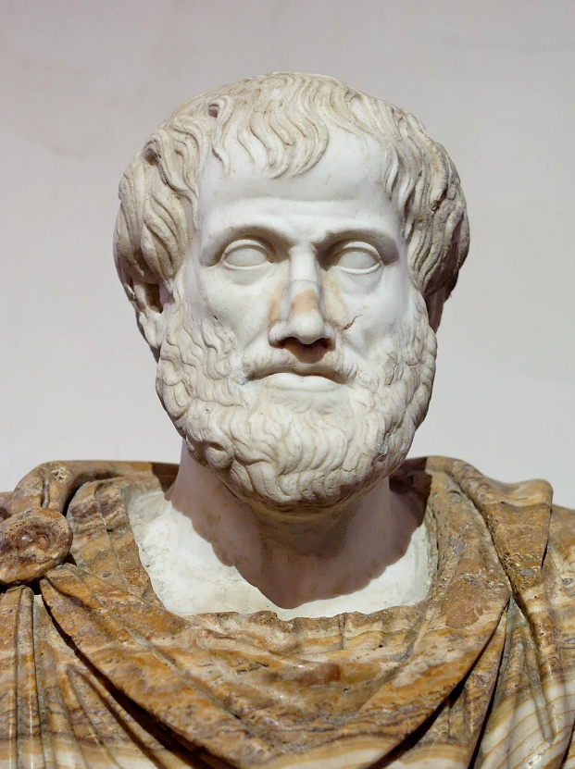
"Virtue is a habit," Aristotle said, meaning a permanent attitude and stable disposition of the soul that is acquired through conscious choice and repetition of actions. It is a moral quality that is achieved through habit. This is true for most skills. Through habit and repetition, we can acquire the skills and attitudes that help us navigate the modern and demanding way of life.

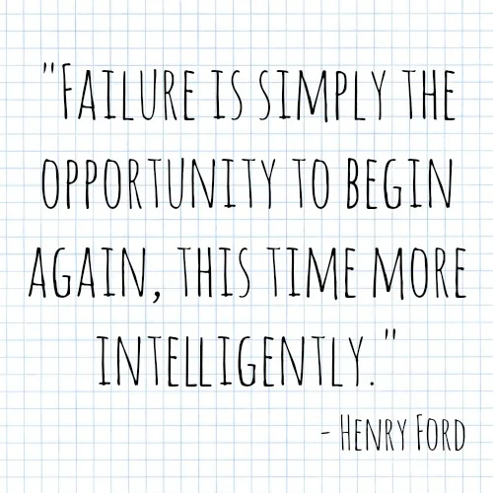

ΑΝΝΕΧ
Stories to share with trainees
Prepared texts for experiential exercise
Instruction for the trainer:
The following texts are given without names. Do not reveal the identity before the group processing is complete.

Story 1 – “The man who lost his creation”
He started with an idea and almost no means. He worked whole nights, believing in his vision more than anything else. The creation grew, became important, gained power.
At some point, he was told that he was no longer the right person to lead it. Others were now making decisions. He was distanced from something that he felt was part of himself.
He was left without a role, without a title, without an identity. For years he believed that he had failed not only professionally, but also as a person. He did not try to return quickly. He first tried to understand who he was without what he had lost.

Story 2 – “The Woman Who Didn’t Believe Her”
She lived in insecurity. Without a steady job, with responsibility for a child, and with the feeling that her life had become shorter. But she had a story in mind.
She wrote it over and over again. She sent it to people who could tell her if it was worth it. The answers were almost always the same: “No.”
The rejection wasn’t just professional. It was existential. She began to believe that perhaps she had nothing substantial to offer. At some point she realized that she was no longer writing to succeed, but to endure. That changed everything.

Story 3 – “The Man of Countless Failures”
Each time she thought she was getting closer. Each time she failed. The results didn’t work, others doubted, doors closed. The failures were so many that they became a number. Each one seemed to prove that he couldn’t do it.
When asked why he kept going, he said he was just learning. He didn’t see failures as proof of incompetence, but as steps toward revelation. He kept going when most people would have stopped.

The trainer can share the following revelations after the exercise and follow up with further discussion.

Story 1 – Steve Jobs
The man who was fired from the company he founded (Apple) in 1985.
For years, he was considered “difficult,” “unfit for leadership,” and overly idealistic. During his time away, he founded NeXT and acquired Pixar. When he returned to Apple, he didn’t try to make it the same as before—he essentially re-founded it. Failure didn’t change him superficially. It forced him to mature as a person and a leader.

Story 2 – J.K. Rowling
When she wrote the first Harry Potter book, she was unemployed, a single mother, and living on welfare. She had been diagnosed with depression and described the period as “the lowest point of her life.” The manuscript was rejected by 12 publishers.
She has said that failure helped her strip her life of what was not essential. As she later said: “Failure freed me, because I stopped pretending.”

Story 3 – Thomas Edison
Before he achieved the practical electric light bulb, he conducted hundreds of failed experiments. His failures were systematically recorded — he did not hide them. When asked about his failures, he replied that he simply discovered ways that did not work. Many of his contemporaries considered him stubborn and wasteful. For him, failure was not a defeat of character but an integral part of creation.

Here is a fantastic story from someone who failed and ultimately didn’t make it. He really had to give up his dream and do something else. It’s important to keep in mind that sometimes in life there is that too.

“The musician who became a teacher”
Dimitris wanted to become a professional musician. Not an amateur. Not “playing for a hobby”. He studied music, went to a conservatory, dedicated hours every day. Until he was 30, he lived on little, doing odd jobs to be able to continue. He played in bands, on small stages, at festivals. He wasn’t bad. He was good. But not good enough to make a living from it.
The rejections weren’t spectacular.
They were quiet:
– “We’ll call you”
– “Not this time”
– “We need something different”
At 35, he realized he had no insurance, he couldn’t make plans, and the dream began to cause him more anxiety than joy. The hardest moment wasn’t when he failed an audition. It was when he admitted that what he imagined would never happen.
He stopped chasing concerts.
He took exams and became a music teacher at a school.
He didn’t “get it right.”
He didn’t become famous.
Some days he still mourns the dream he left behind.
But he lives steadily.
And when one of his students plays a piece correctly for the first time, he thinks:
“Maybe this was my place.
Not on stage, but here.”

